Certificate of Analysis

Product: Goat anti-Rabbit IgG (H&L), DyLight® 594 Conjugate

Part Number: GtxRb-003-D594NHSX
Lot Number: 69-40-061419
Amount: 1.0 mg of lyophilized antibody (E ^{1%} at 280 nm = 13.0)
Fluorophore: DyLight® 594 (Ex = 593 nm; Em = 618 nm)
Fluor/Protein Ratio: 5.1 Moles DyLight® 594 per Mole Antibody
Purification: Antibody was affinity purified using solid phase Rabbit IgG
Purity: Affinity purified antibody is > 95 % based on SDS-PAGE
Host: Goat
Immunogen: Purified Rabbit IgG, whole molecule
Buffer: 10 mM Sodium Phosphate, 0.15 M Sodium Chloride, pH 7.2,
1 % (w/v) BSA, Protease/IgG free
Preservative: 0.05 % (w/v) Sodium Azide
Reconstitution: Rehydrate with 1.1 ml of deionized water. Allow reconstituted product to stand at room temperature for at least 30 minutes prior to dilution. If necessary, centrifuge to remove any particulates. Prepare fresh working dilution daily.
Storage: Store lyophilized material at 2-8 ºC. For storage at -20 °C after reconstitution, dilute with an equal volume of glycerol to prevent loss of enzymatic activity. Prepare working dilution prior to use and then discard.
Shelf Life: 1 year from date of receipt
Specificity: Based on IEP, this antibody reacts with:
- heavy (γ) chains on Rabbit IgG
- light chains on all Rabbit immunoglobulins
Cross Reactivity: Based on IEP, no reactivity is observed to:
- non-immunoglobulin Rabbit serum proteins
Country of Origin: Goat serum was obtained from healthy animals of US origin and under the care of a registered veterinarian.
Note: This conjugate was prepared using Part # GtxRb-003-D, Lot # 41-191-091217.

Applications: This conjugate is suitable for immunomicroscopy and flow cytometry. The optimal working dilution should be determined by the investigator. Suggested starting dilution(s):
- 1:20 – 1:2,000 for most applications

Disclaimer: For in vitro Laboratory Use Only. Not for diagnostic or therapeutic use. Not for human or animal consumption. The proper selection and use of our products is the sole responsibility of the end user, and therefore we can offer no guarantee to a specific experimental outcome. Suggested applications of our products are not recommendations to use our products in violation of any patent or as a license under any patent of ImmunoReagents, Inc.

Product may not be resold or modified for resale without prior written approval of ImmunoReagents, Inc.

Testing Results

PRODUCT: Goat anti-Rabbit IgG (H&L), DyLight® 594 Conjugate
Part NUMBER: GtxRb-003-D594NHSX
LOT NUMBER: 69-40-061419

TESTS SPECIFICATIONS RESULTS

Appearance: Red to purple powder PASS

Purity: Two predominant bands at 50 and 24 kDa based on SDS-PAGE PASS

Specificity: Based on IEP, this antibody has precipitin bands with:
- heavy (γ) chains on Rabbit IgG PASS
- light chains on all Rabbit immunoglobulins PASS

Cross Reactivity: Based on IEP, no precipitin bands are observed to:
- non-immunoglobulin Rabbit serum proteins PASS

FLISA: Mean fluorescent value of 8 µg/ml of DyLight® conjugate 667 MFI’s
when tested against Rabbit IgG coated at 4 µg/ml

F.I.T.: Mean fluorescent intensity of a 1:1000 dilution at 1259 MFI’s
Ex-593 nm (+/-9)/Em-618 nm (+/-9)

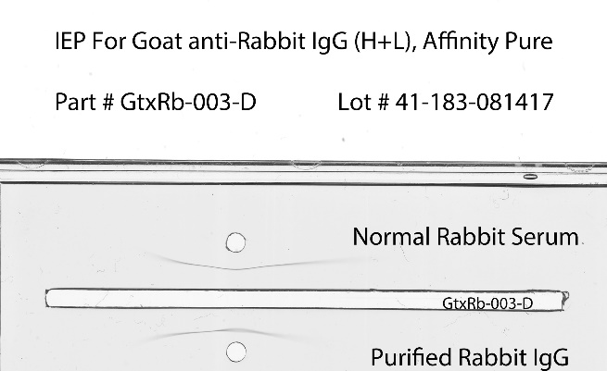
SDS-PAGE Immunoelectrophoresis (IEP)

1 2

55kDa

31kDa

21kDa

- GtxRb-003-D, Lot # 41-191-091217
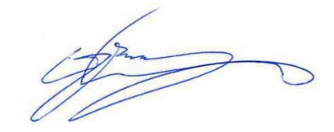
- Mol Weight Standard

Date: June 20, 2019 Signature: __________________________________
Quality Control

