**Certificate of Analysis**

Product: Rabbit anti-Llama IgG (H&L), Affinity Pure

Part Number: RbxLl-003-D

Lot Number: 27-169-011614

Concentration: 8.83 mg/ml (E 1% at 280 nm = 13.0)

Amount: 1.0 mg

Form: Clear, colorless liquid, 0.2 µm filtered

Purification: Affinity purified using solid phase Llama IgG

Purity: > 95% based on SDS-PAGE

Host: Rabbit

Immunogen: Purified Llama IgG, whole molecule

Buffer: 10 mM Sodium Phosphate, 0.15 M Sodium Chloride, pH 7.2

Preservative: 0.05 % (w/v) Sodium Azide

Storage: 2-8 º C

Expiration Date: April 10, 2020

Specificity: Based on IEP, this antibody reacts with:

* heavy (γ) chains on Llama IgG
* light chains on all Llama immunoglobulins

Cross Reactivity: Based on IEP, no reactivity is observed to:

* non-immunoglobulin Llama serum proteins

Country of Origin: Rabbit serum was obtained from healthy animals of US origin and under the care of a registered veterinarian.

Applications: Suitable for use in: ELISA, WB, IHC, ICC, CL, FACS, IM, IF

The optimal working dilution should be determined by the investigator.

Disclaimer: *For in vitro Laboratory Use Only.* Not for diagnostic or therapeutic use. Not for human or animal consumption. The proper selection and use of our products is the sole responsibility of the end user, and therefore we can offer no guarantee to a specific experimental outcome. Suggested applications of our products are not recommendations to use our products in violation of any patent or as a license under any patent of ImmunoReagents, Inc.

**Product may not be resold or modified for resale without prior written approval of ImmunoReagents, Inc.**

Rev.3 041018TB

**Testing Results**

**Product:** Rabbit anti-Llama IgG (H&L), Affinity Pure

**Part NUMBER:** RbxLl-003-D

**Lot NUMBER:** 27-169-011614

**TESTS SPECIFICATIONS Results**

Appearance: Clear and Colorless PASS

Purity: Two predominant bands at 50 and 24 kDa based on SDS PAGE PASS

Specificity: Based on IEP, this antibody has precipitin bands with:

* heavy (γ) chains on Llama IgG PASS
* light chains on all Llama immunoglobulins PASS

Cross Reactivity: Based on IEP, this antibody does not have precipitin bands to:

* non-immunoglobulin Llama serum proteins PASS

**SDS PAGE** **Immunoelectrophoresis (IEP)**

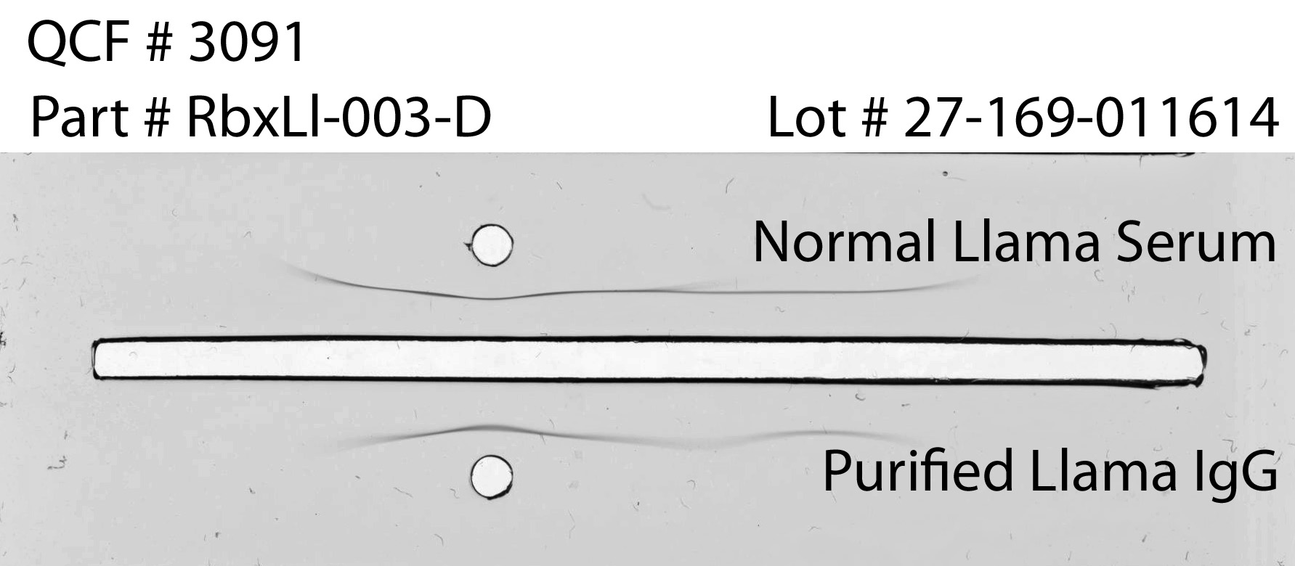

**1 2**

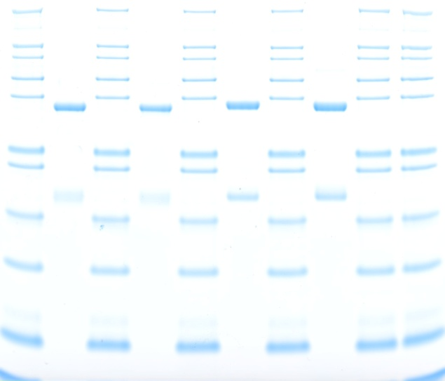

55kDa

31kDa

21kDa

1. RbxLl-003-D, Lot # 27-169-011614
2. Mol Weight Standard



Date: April 10, 2018 Signature: __________________________________

Quality Control